



**E-PROJECT REPORT**

**Alpine Ascents**

Theme: mountaineering and hiking

Category: Website Design

**Project Instructor:**

Miss. Aruba Tajwar

**Submitted to: eproject@aglsm.com**

Aptech fb area

center

**Group Member**

Student1502072 Habib ul Hasan

Student1502069 Muhammad Kabir Siddique

**ACKNOWLEDGEMENT**

We would like to express our special thanks of gratitude to our project instructor (Miss ARUBA) who gave us the golden opportunity to do this wonderful project on the topic (ALPINE ASCENTS), which also helped us in doing a lot of Research and we came to know about so many new things. We are really thankful to them.

**THANK YOU!**

|  |  |  |  |  |  |
| --- | --- | --- | --- | --- | --- |
| **S.NO** | **TASK** | **STARTING**  **DATE** | **DAYS** | **TEAM**  **MEMBER**  **NAME** | **STATUS** |
| **1** | **Information**  **Collecting** | **19/10/23** | **3 DAYS** | **Habib ul Hassan** | **Completed** |
| **2** | **Making logo** | **21/10/23** | **1 DAYS** | **Kabir Siddique** | **Completed** |
| **3** | **Making layout/page** | **26/10/23** | **5 DAYS** | **Habib ul Hassan, Kabir Siddique** | **Completed** |
| **4** | **Smooth navbar and connecting links** | **28/10/23** | **2 DAYS** | **Habib ul Hassan** | **Completed** |
| **5** | **Image collecting** | **1/11/23** | **3 DAYS** | **Kabir Siddique** | **Completed** |
| **6** | **Working on home page and gallery page** | **6/11/23** | **5 DAYS** | **Habib ul Hassan, Kabir Siddique** | **Completed** |

**Table of Contents**

1. **Introduction**
   1. Background and Necessity for the Website
2. **Project Overview**
   1. Scope of Project
   2. Constraints
3. **Requirements Analysis**
   1. Functional Requirements
   2. Non-Functional Requirements
4. **Interface Specifications**
   1. Hardware
   2. Software
5. **Design and development**
   1. Architecture of web application
   2. Data Flow Diagram (DFD)
   3. Source Code
6. **User Guide**
   1. System Requirement
7. **Realizing Success: Project Deliverables**
   1. Delivering Excellence: The Fruits of Our Endeavors
8. **Introduction:**

**1.1 Background and Necessity for the Website**

The necessity for a plant nursery website arises from the surge in gardening interest, demand for plants, and online shopping convenience. This stems from factors like the growing fascination with gardening for relaxation and aesthetics. A website is crucial due to the diverse range of plant species nurseries offer, each with unique traits and care needs. Such a platform lets nurseries showcase their collection and helps customers make informed choices.

The website provides accessibility and convenience by allowing customers to browse and purchase plants online, transcending geographical boundaries and store hours. It acts as an information hub, offering details about each plant species, fostering responsible gardening practices, and matching plants to customers' environments. The site's search and filtering features aid users in efficiently finding plants aligned with their preferences, saving time and enhancing the overall experience.

Furthermore, the website facilitates customer engagement and loyalty through features like wish lists, personalized recommendations, and informative blogs. This strengthens the connection between nurseries and customers, encouraging repeat purchases and referrals. In essence, the digital platform serves as an educational, transactional, and interactive haven for both avid gardeners and those discovering the joy of nurturing plants.

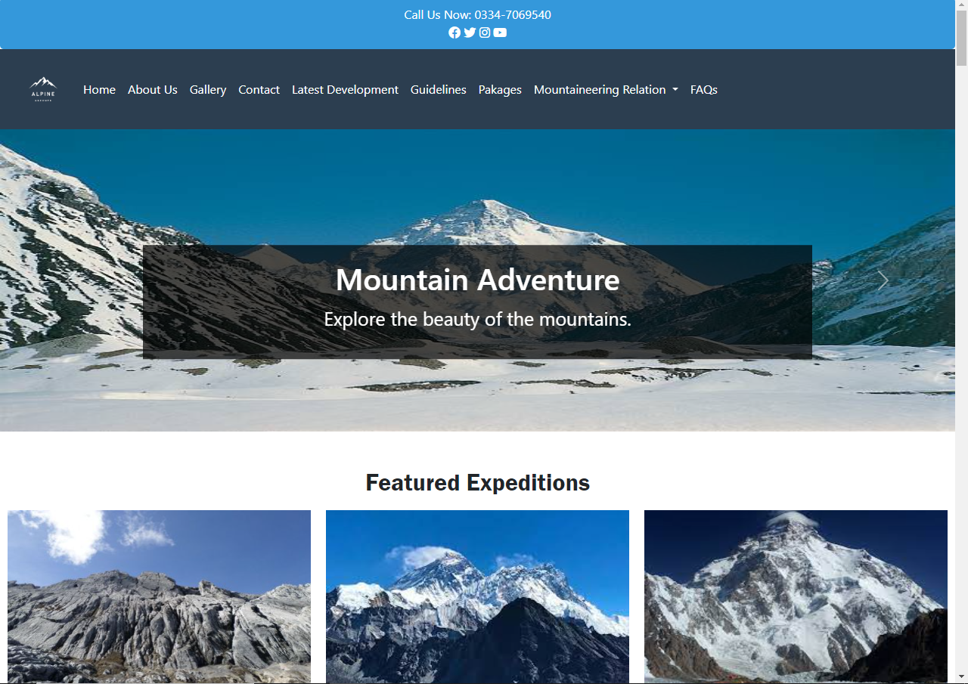

1. **Project Overview.**

Alpine ascents emerges as an integrated digital hub, merging e-commerce and botanical exploration seamlessly. Designed for plant enthusiasts, the platform offers an all-encompassing online experience. By uniting shopping and plant-related knowledge, 'PlantPalace' simplifies the process of exploring and acquiring diverse plant species. Users can expect organized selections, powerful search tools, and detailed insights into each plant's origin and care.

This document serves as a comprehensive guide to 'PlantPalace,' highlighting its multifunctional essence. The platform empowers users to embark on an immersive botanical journey, facilitating plant purchases and providing botanical insights. This concise document outlines the project's objectives, functionalities, user interface, and operational scope. Catering to stakeholders and developers alike, it ensures a shared understanding of 'Plant Palace’s' aspirations and implementation.

**2.1 Scope of Project**

This Web portal will be a responsive and visually appealing Website to be used by individuals.

**2.2 Constraints**

The web portal will notably lack a storage capability on its server. Instead, data retrieval will be achieved through JSON/TXT files, presenting users with visible content. Nevertheless, the portal will abstain from enabling information alteration within these files directly from its interface.

1. **Requirement Analysis:**

**3.1 Functional Requirements**

* **Pages and menus**
* Catalog Display
* Navigation
* Mountains Information
* Gallery
* Feedback
* Contact Us
* Sitemap

**3.2 Non Functional Requirements**

* Website Security
* User Accessibility
* Intuitive User Experience
* Operational Reliability
* Optimal Performance
* Scalability
* Continuous Availability
* Cross-Browser Compatibility

1. **Interface Specification**
   1. **Hardware**

Intel Core i5 Processor or higher, 8 GB RAM or higher, Color SVGA, 500 GB Hard Disk space, Mouse, Keyboard

**4.2 Software**

HTML5, CSS3, Bootstrap (optional), JavaScript, jQuery, draw.io.

1. 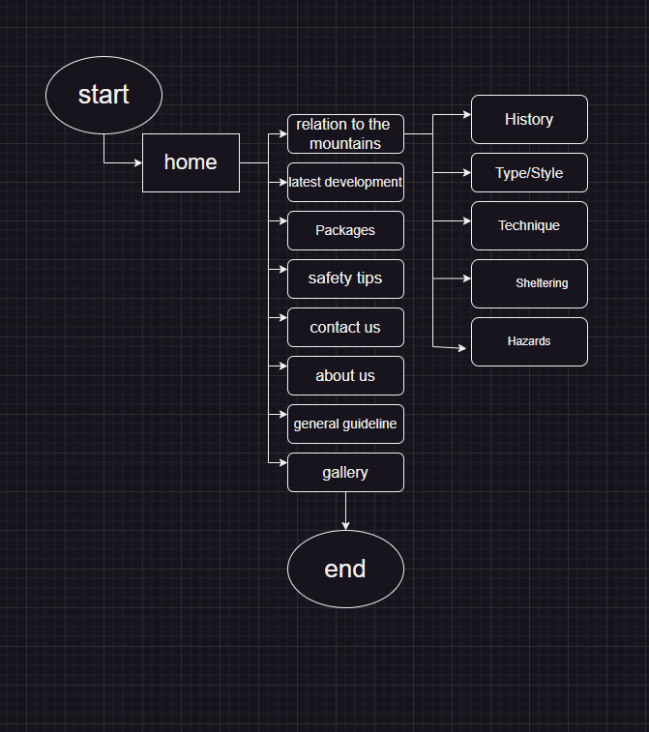**Design and Development**

* **Data Flow Diagram (DFD)**

* **Architecture of web application**

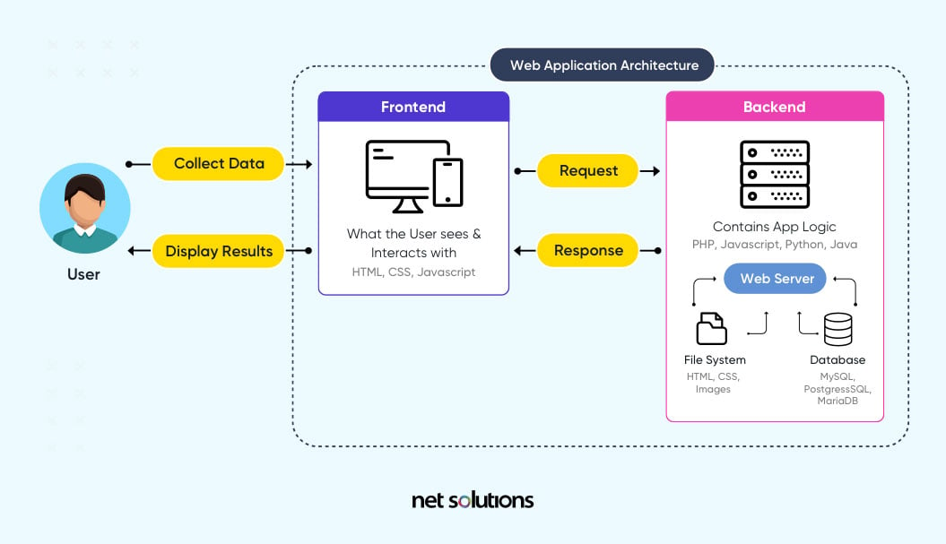

1. **User Guide:**

The thirst for learning, upgrading technical skills and applying the concepts in real life environment at a fast pace is what the industry demands from IT professionals today. However busy work schedules, far-flung locations, unavailability of convenient time-slots pose as major barriers when it comes to applying the concepts into realism. And hence the need to look out for alternative means of implementation in the form of laddered approach.

The above truly pose as constraints especially for our students too! With their busy schedules, it is indeed difficult for our students to keep up with the genuine and constant need for integrated application which can be seen live especially so in the field of IT education where technology can change on the spur of a moment. *Well, technology does come to our rescue at such times!!*

Keeping the above in mind and in tune with our constant endeavour to use Technology in our training model, we at Aptech have thought of revolutionizing the way our students learn and implement the concepts using tools themselves by providing a *live and synchronous eProject learning environment!*

**So what is this eProject?**

eProject is a step by step learning environment that closely simulates the classroom and Lab based learning environment into actual implementation. It is a project implementation at your fingertips!! An electronic, live juncture on the machine that allows you to

* Practice step by step i.e. laddered approach.
* Build a larger more robust application.
* Usage of certain utilities in applications designed by user.
* Single program to unified code leading to a complete application.
* Learn implementation of concepts in a phased manner.
* Enhance skills and add value.
* Work on real life projects.
* Give a real life scenario and help to create applications more complicated and useful.
* Mentoring through email support.

The students at the centre are expected to complete this eProject and send complete documentation with source code to eProjects Team

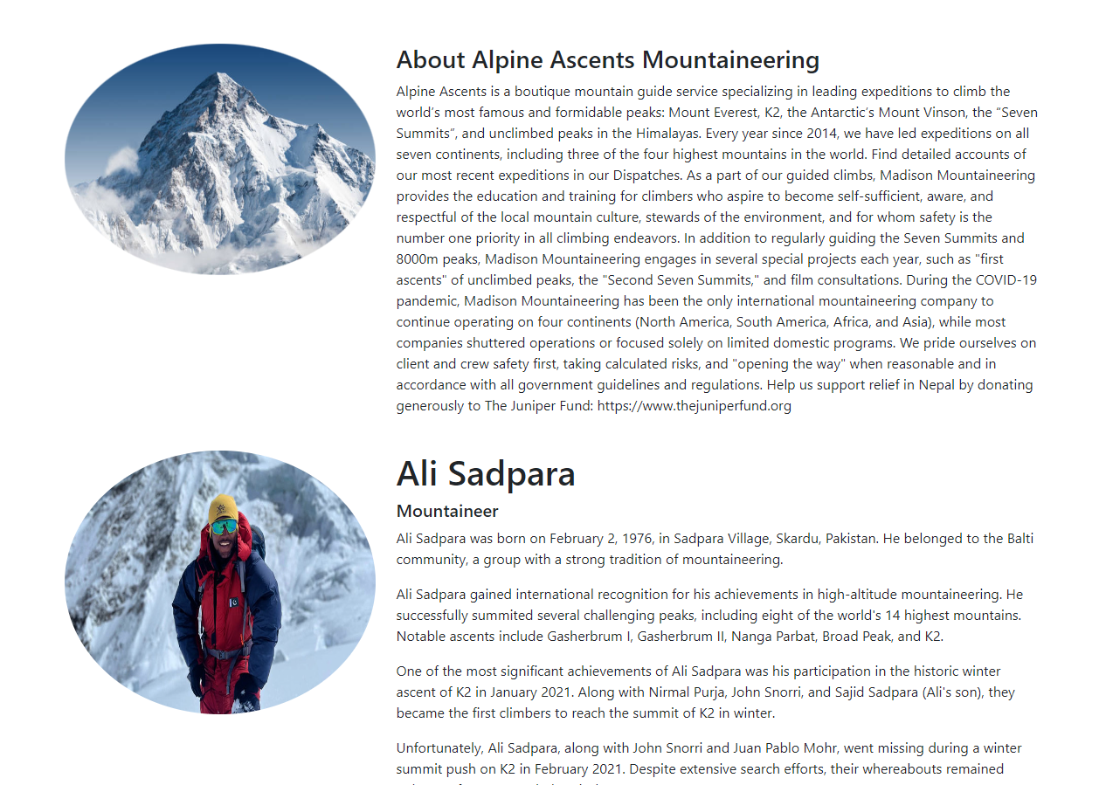Looking forward to a positive response from your end!!

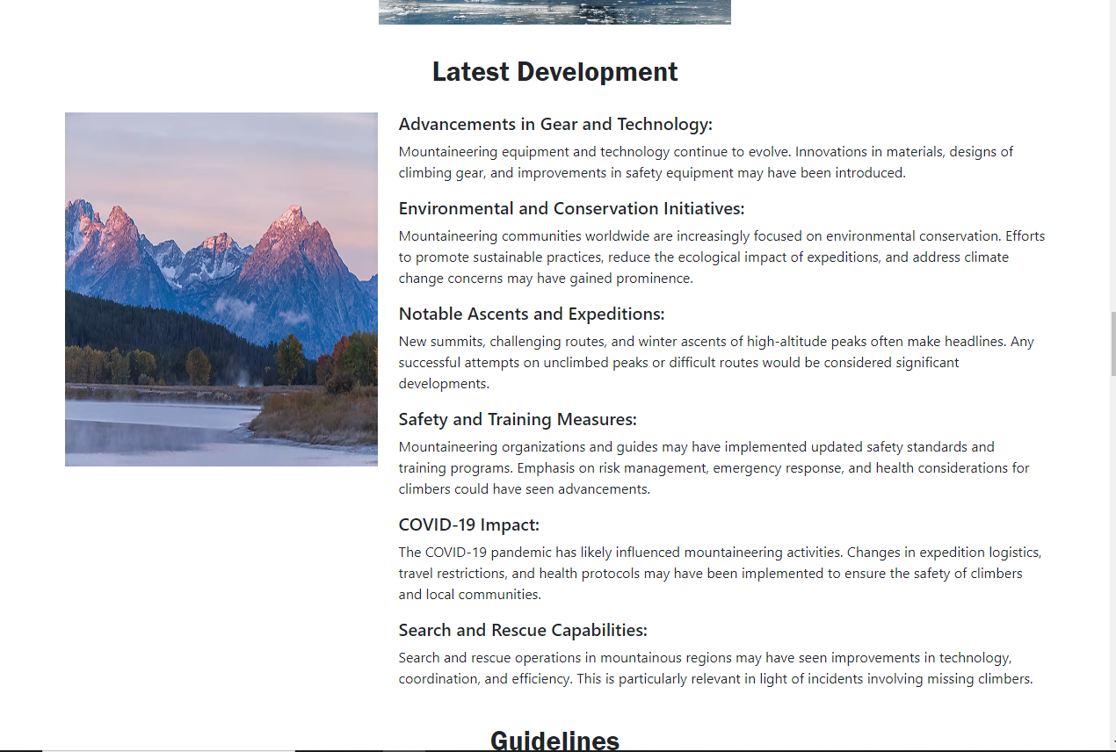

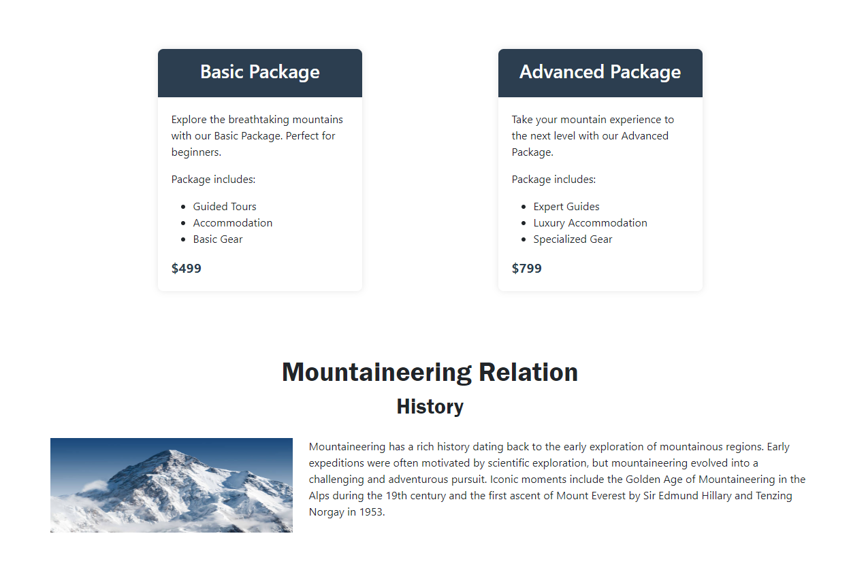

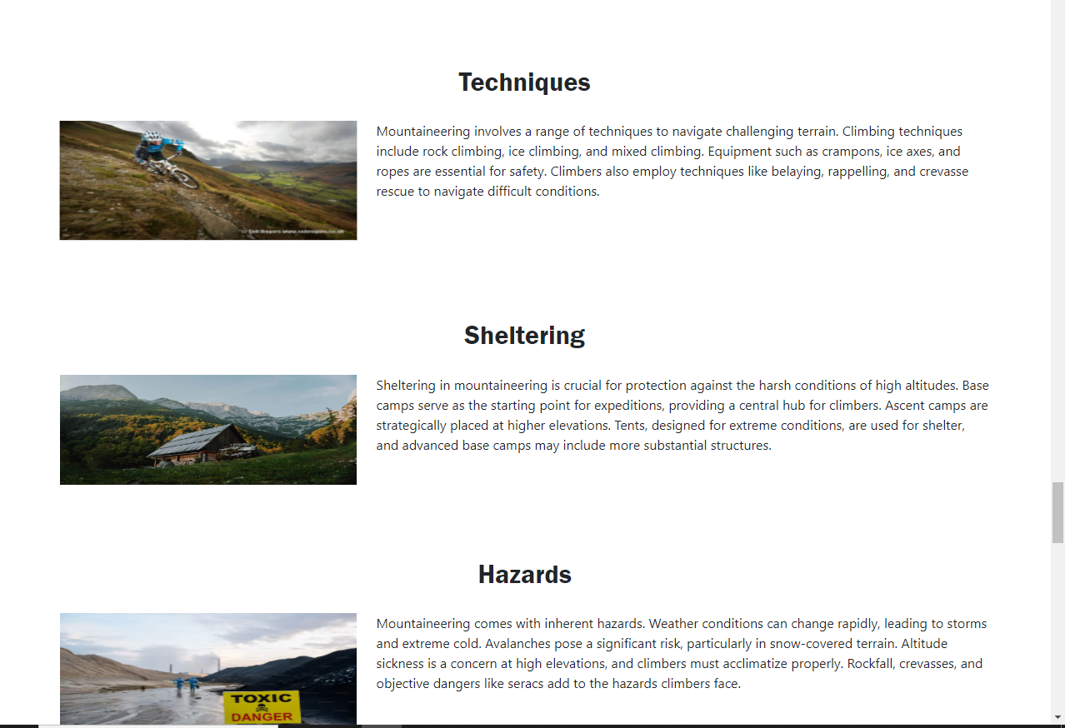

1. Developer Guide:

In today's IT industry, there's a pressing demand for professionals to continuously learn, upgrade their technical skills, and effectively apply these concepts in practical settings. However, busy schedules, distant locations, and limited time slots often act as significant hurdles in translating these concepts into real-world scenarios. This situation presents a challenge for both industry professionals and students alike, making it difficult to keep up .

At Aptech, we recognize these constraints and understand the necessity for an innovative approach to bridge this gap. To address these challenges, we've conceived a transformative solution known as the eProject—a dynamic learning environment designed to revolutionize how our students comprehend and implement concepts using interactive tools, creating a live and synchronized learning experience.

But what exactly is eProject?

eProject represents a structured learning environment that mirrors traditional classroom and lab-based settings, enabling practical implementation step by step. It serves as an electronic platform, placing project implementation at your fingertips. Here's what you can achieve through eProject:

* Progress through a structured, step-by-step learning approach.
* Construct more comprehensive and robust applications.
* Utilize specific utilities within user-designed applications.
* Unify disparate code into a cohesive single program, resulting in a complete application.
* Learn how to implement concepts in incremental stages.
* Enhance skills and bring value to your learning.
* Engage in real-life project work.
* Confront and resolve complex challenges within real-life scenarios.
* Receive mentoring and support through email assistance.

Students are encouraged to complete the eProject, submitting comprehensive documentation along with the source code to the eProjects Team.

We eagerly await your positive response and participation in this innovative learning endeavor

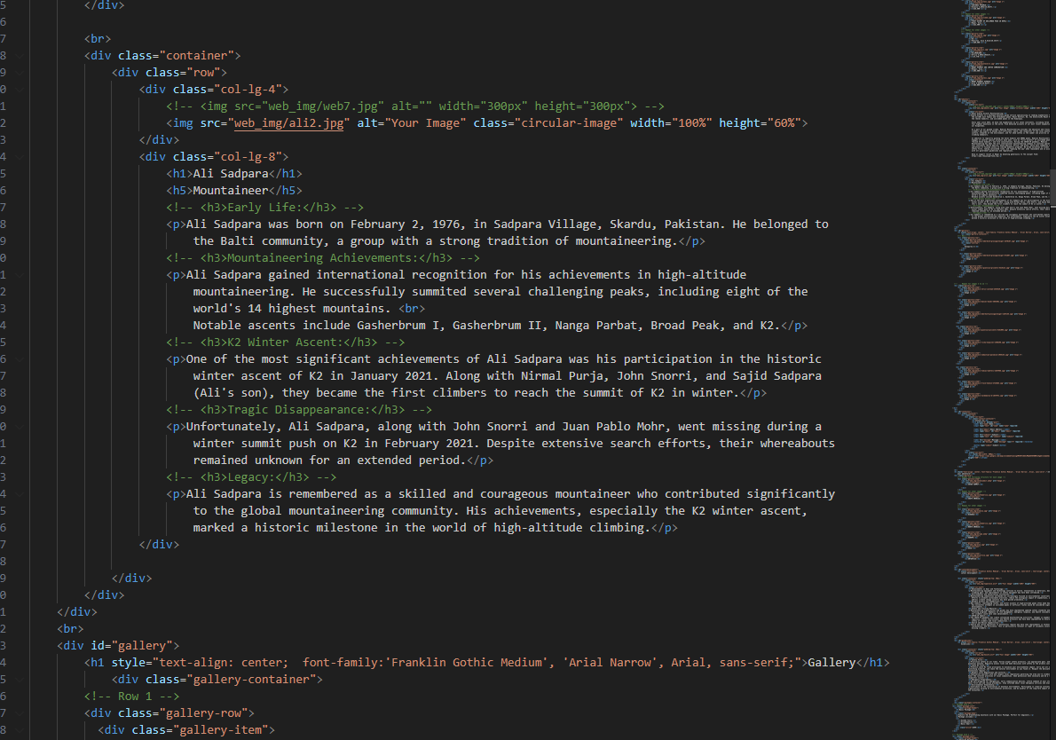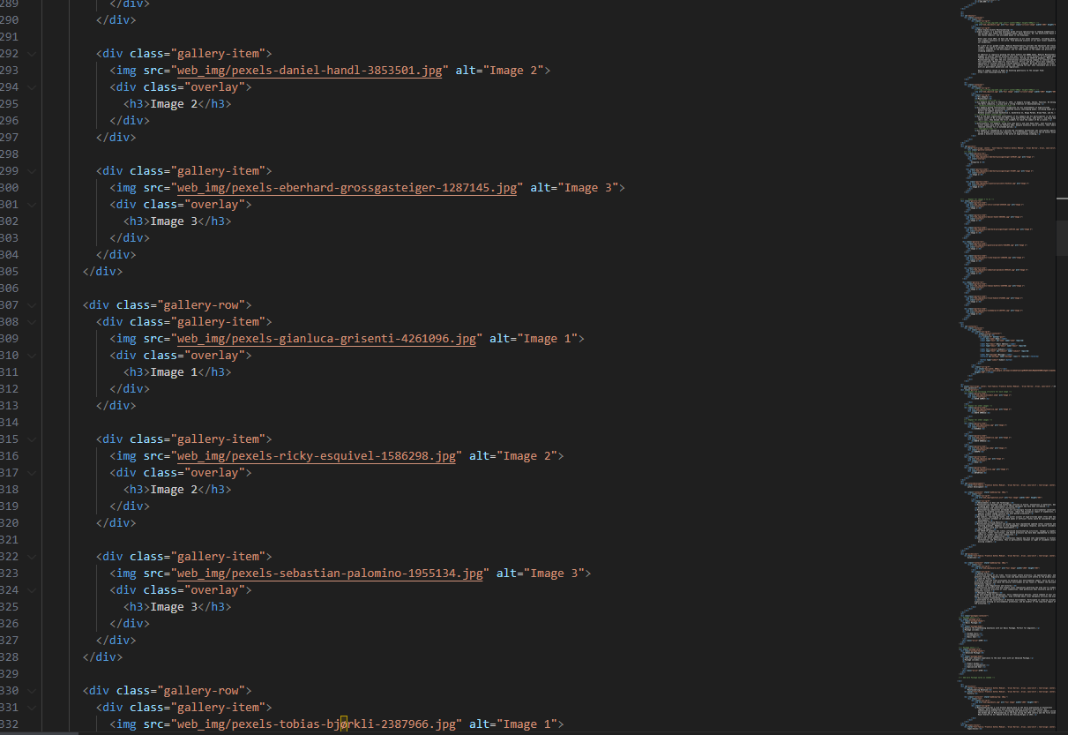

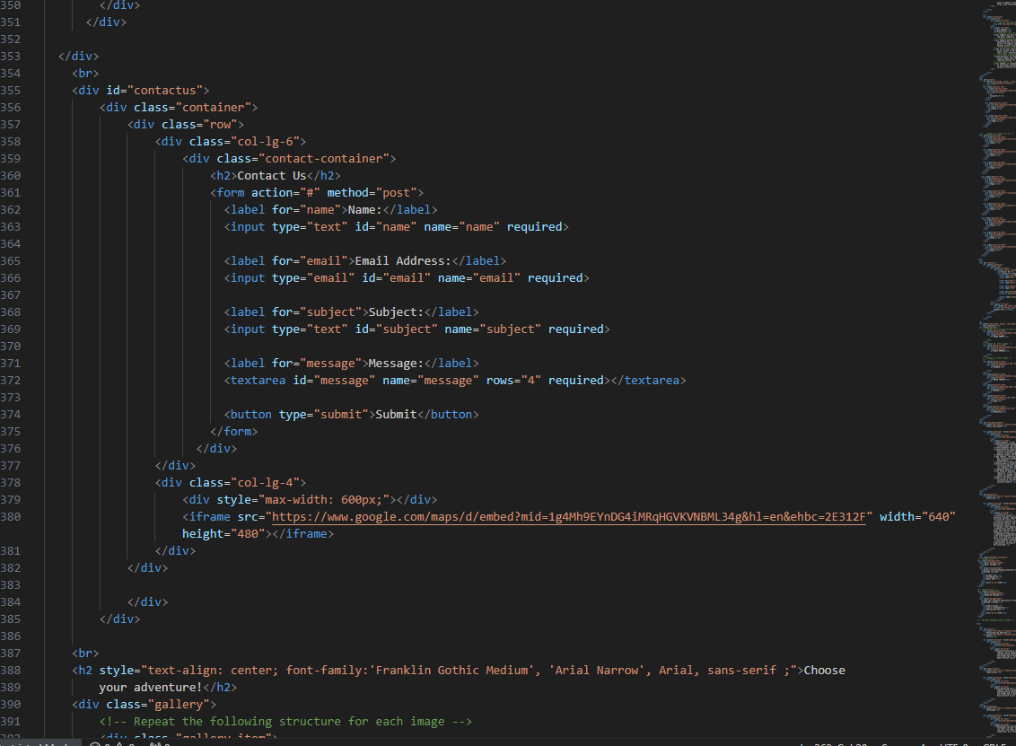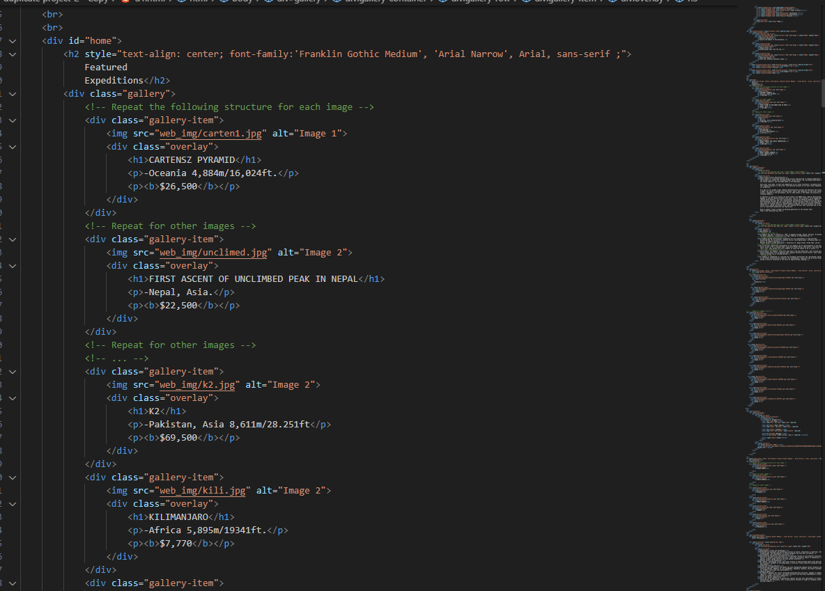



* 1. **System requirement**

|  |  |  |
| --- | --- | --- |
|  |  | description |
| 1. | s.no | Items |
| 2. | Software | Visual studio code 2017 or higher |
|  |  |  |

1. **Realizing Success: Project Deliverables**

[add some front end picture here ]